5.1.1 LEAP YEAR
ALGORITHM
Step 1: Start
Step 2: Read the year
Step 3: Check if
The year is divisible by 400
OR the year is divisible by 4 and not divisible by 100
Step 4:If the condition is true, print "Leap year"Else, print "Not a leap year"
Step 5: Stop
FLOWCHART
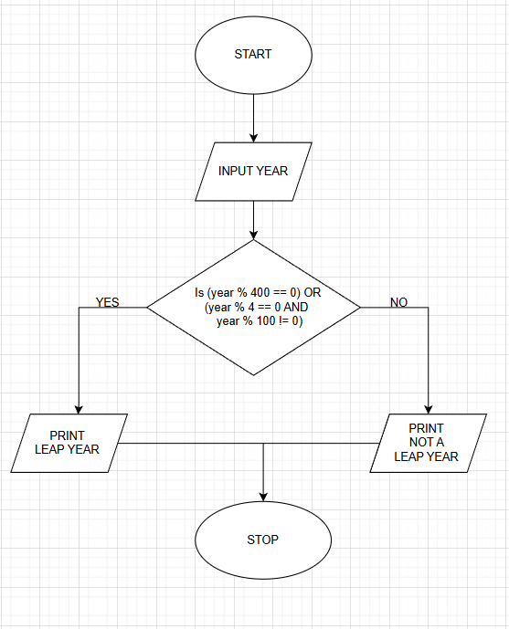
PROGRAM
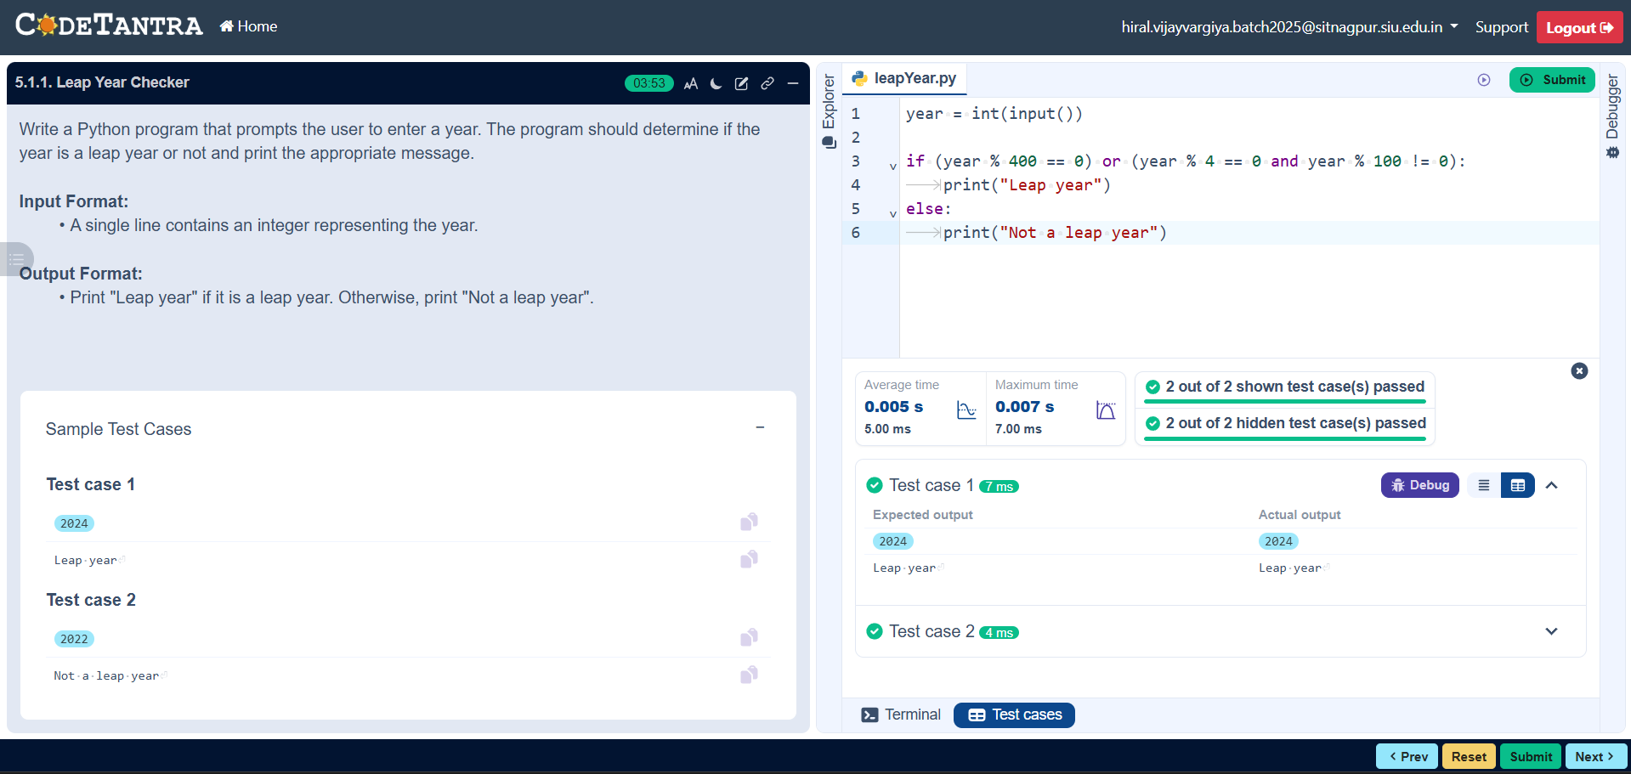

5.1.2 STUDENT GRADES
ALGORITHM
- Start
- Input marks of four subjects (m1, m2, m3, m4)
- Calculate total
$$total=m1+m2+m3+m4$$
- Calculate aggregate percentage
$$aggregate=total/4$$
- If aggregate > 75
→ grade = "Distinction"
- Else if aggregate ≥ 60
→ grade = "First Division"
- Else if aggregate ≥ 50
→ grade = "Second Division"
- Else if aggregate ≥ 40
→ grade = "Third Division"
- Else
→ grade = "Fail"
- Print total
- Print aggregate (two decimal places)
- Print grade
- Stop
PROGRAM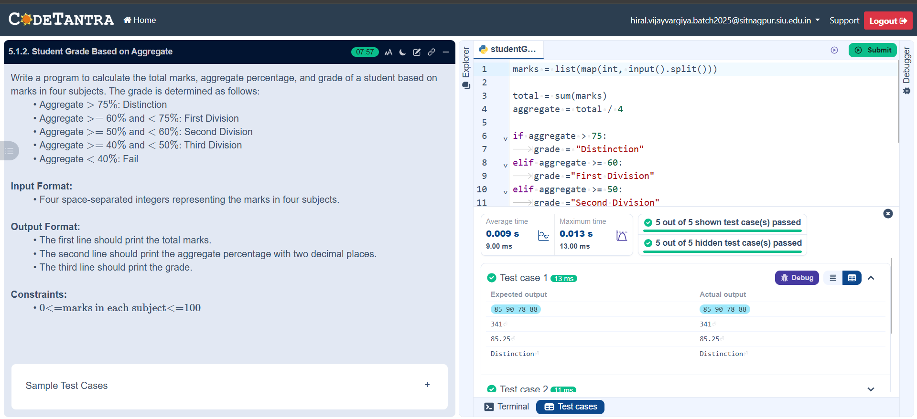
FLOWCHART
